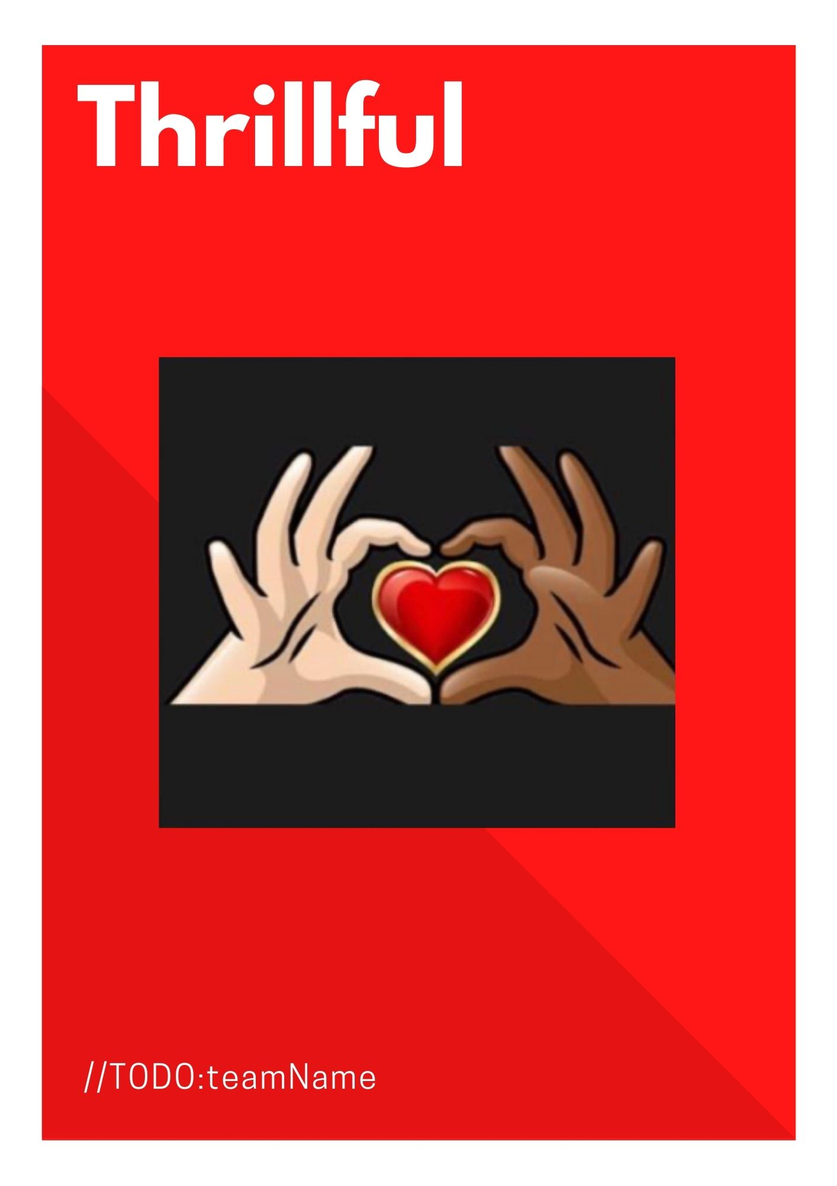

**Table of Contents**

//TODO:teamName

Project Overview

Software Proposal for Thrillful……….…………………………………..Pg 3

Project Overview…………….…………………………………………...Pg 3

Estimate of Effort……….………………………………………………..Pg 4

Cost Estimate And Payments Terms……….…………………………….Pg 5

Possible Issues………………………….………………………………..Pg 5

Software Development Agreement….…………………………………..Pg 5

Domain Models………………………………………………………..…………………......Pg 7

UI Diagrams……………………………………………………..…………………………...Pg 8

Schedule……………………………………………………………………………..………..Pg 16

**Software Proposal for Thrillful**

An e-commerce website

**Current needs:**

*Administration and Operations*

* Add, update, and remove inventory
* Add update and remove sales banners
* Manage users
* Manage sales
* Marketing

*User Experience*

* Searchability on all products offered
* User profiles
* Reviews
* Ratings
* Site navigation
* Site design

**Web Application Proposal and Project Overview**

The goal of this project is to develop a user-friendly e-commerce web application that utilizes the client’s existing Shopify backend that is easy to manage for the client, as well as easy to navigate for the end-user. Thrillful will be deployed on a hosting platform of the client’s choosing, and the backend will utilize a plug-in to monitor and track sales, inventory, and shipping. The app will include an internal-facing “help” documentation to give the client support when creating new products and categories, as well as marketing products to customers.

We propose the following features to the web site:

* Internal facing administrative pages to manage inventory
* Add/update/delete products
* Add/Update/Delete sales banners
* Internal facing administrative pages to manage end-users
* Add/Delete users
* User Experience
* Registration. Users will be able to register on the site to create a profile. A user profile will be unique to them, allowing them to look at past orders, update contact information, as well as leave reviews and ratings on products they have purchased.
* Searchability. Users will be able to search the site based on category.
* User-friendly site navigation with a consistent layout.
* Contact Form
* Admin Support Documentation
* Accessible in the admin view as a guide for site’s functionality and how to utilize it.

**Estimate of Effort**

* We will use an “agile” approach in which we work in two-week “sprints”. In each sprint, we will implement a subset of the application’s features. Each sprint will progress in this way:
* At the beginning of each sprint, we will meet with you to decide:
  + Which features to implement and their priorities.
  + The maximum number of hours you authorize us to work
* We will implement and test the features.
* At the end of the sprint, we will meet with you to:
  + Demonstrate the features we have added to the app.
  + Get your feedback on any changes you would like us to make.
* We can allocate at least 50 hours per week of developer time to this project. At 50 hours per week, here is the projected project duration for the project:
* **Thrillful e-commerce web application utilizing Shopify plugins: thirteen weeks.**

**Front-End**

* Home View - *50 hours*
* Admin View - *50 hours*
* Login View - *50 hours*
* Reviews and Ratings - *75 hours*
* Checkout View - *50 hours*
* Navigation - *25 hours*

**User Experience**

* Search Bar - *25 hours*

**Backend**

* Login backend: Implement sign-in/sign-up on back-end. - *50 hours*
* Administrative backend: Create administrative views for user management, help documentation, and Shopify administration. Administrative features for editing inventory and discounts. - *75 hours*
* Connecting to existing Database and inventory - *50 hours*
* Add more product categories for future growth - *50 hours*

**Project Management**

* Planning and Tracking - *50 hours*
* Documentation - *50 hours*

**Rough Estimate**

* Winter term 150 hours
* Spring term 500 hours
* Project total 650 hours

**Cost Estimate And Payments Terms**

* Since Thrillful is allowing our team to develop their site for our capstone project at Lane Community College, we are offering a discounted hourly rate of $0 per hour. (Our normal rate is $75 per hour for development and $125 per hour for management.) At the discounted rate, these are the cost estimates:
* **Thrillful e-commerce web app: $0**

**Possible Issues**

* These are features that may take longer than estimated due to unforeseen technical issues:
  + Plugging in Shopify backend
  + Creating a cart and payment portal that connects to Shopify

**Software Development Agreement**

1. This Software Development Agreement (the “Agreement”) states the terms and conditions that govern the contractual agreement between a Lane Community College student team consisting of Robyn Brittain, Georgia Fox, Sandi Jasmer, and Shawna Staff, (the “Developer”), and Jasmine Wells having his principal place of business at 311 N 10TH AVE, Sterling, CO 80751 (the “Client”) who agree to be bound by this Agreement. WHEREAS the Client has conceptualized the Thrillful Ecommerce (the “Software”), which is described in further detail in the first section of this document, and the Developer is a contractor with whom the Client has come to an agreement to develop the Software.
2. NOW, THEREFORE, in consideration of the mutual covenants and promises made by the parties to this Software Development Agreement, the Developer and the Client (individually, each a “Party” and collectively, the “Parties”) covenant and agree as follows:
3. DEVELOPER’S DUTIES. The Client hereby engages the Developer and the Developer hereby agrees to be engaged by the Client to develop the Software in accordance with the specification described above and any changes requested by the client during the development process.
4. CLIENT’S DUTIES. The Client hereby agrees to meet with the Developer at least once every two weeks for two-hour sprint review meetings. The Client will provide the requirements for the Software and evaluate the Software at the end of each sprint to determine if it is meeting the requirements.
5. DELIVERY. We will practice continuous delivery by working in two-week sprints in which we will implement a subset of the application’s features and deliver working software for the client’s evaluation. The deliverables for each sprint will be agreed upon by the client and the developer. Upon completion of each Sprint, the Client shall review the functionality of the Software and communicate both aspects with which they are satisfied and aspects with which they would like to be changed. If there is a delay in delivering the features or changes planned for a sprint, the Developer and the Client shall discuss in good faith at the next Sprint Review Meeting and the Developer shall make use of all available resources to deliver those features or changes in the next sprint.
6. COMPENSATION. In consideration for the Service, the Client shall pay the Company at the rates described in this proposal (the “Pricing”), in accordance with the payment terms.
7. INTELLECTUAL PROPERTY RIGHTS IN THE SOFTWARE. The Parties acknowledge and agree that the Client will hold all intellectual property rights to the Software including, but not limited to, copyright and trademark rights. The Developer agrees not to claim any such ownership in the Software’s intellectual property at any time prior to or after the completion and delivery of the Software to the Client.

1. INDEMNIFICATION. The Developer and Client agree to indemnify, defend, and protect each other from and against all lawsuits and costs of every kind pertaining to the software. The Developer agrees to indemnify, defend, and protect the Client from the Developer’s infringement of the intellectual rights of any third party.
2. IN WITNESS WHEREOF, each of the Parties has executed this Software Development Agreement, both Parties by its duly authorized officer, as of the day and year set forth below.

DEVELOPER

 Robyn Brittain 03/09/2021

[Capstone team member name]      Date

georgia fox 03/09/21

[Capstone team member name]      Date

Sandi Jasmer 3/9/21

[Capstone team member name]      Date

Shawna R. Staff 03/09/2021

[Capstone team member name]     Date

CLIENT ____________________________ ___________________

   [Client name]                                  Date

**Domain Model Description**

An **AppUser** will login in order to leave a **Review** on a **Product**.

An **AppUser** will **Purchase** a **Product** and be able to leave reviews on a **Product** that the user has purchased.

A **Product** will have many **Reviews** and a review will have one and only one **Product.**

An **AppUser** sends an **Email** to Admin with any questions, i.e. a contact form on the website.

An **Email** will have many **Replies**, a **Reply** will only have one **Email**.

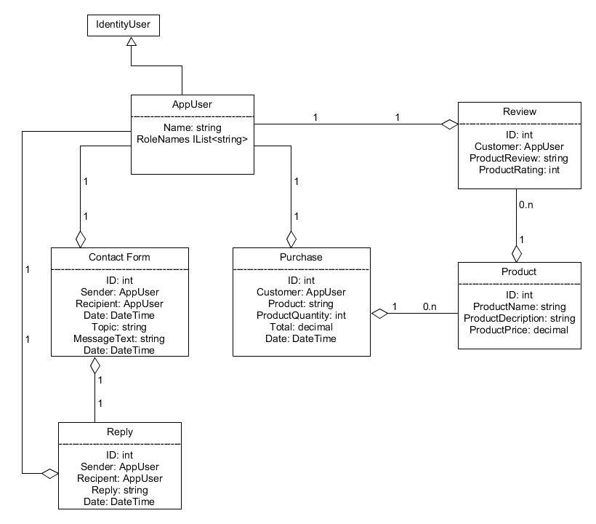

**UI Descriptions**

**Home Page**

This is the landing page for the Thrillful site which presents users with the ability to search for products and categories with a visible banner that will list any promotions that Thrillful has running at the time.

Model Objects: Products (search)

Figure 1

**Product Review**

This page allows the user to leave a review and rate products purchased.

Model Objects: Purchase, Product, Review

Figure 2

**Product View**

The list of products after the user performs a search for products. The user can see the description and select the product to show more options pertaining to the product.

Model Objects: Product, Review

Figure 3

**Admin View**

This view is when the admin logs in and has access to add products, view orders, edit users, and add a promotional banner.

Model Objects:

Figure 4

**Admin Banner**

This view is how the admin can upload an image for the seasonal banner.

Model Objects: This uploads an image and is not saved to a DB.

Figure 5

**Admin Support Documentation**

This page is the help documentation that gives the steps for the admin on how to add/update/remove products, how to add a banner, edit users, etc…

Models Objects: None, just a view with text.

Figure 6

**Admin View of Users to Edit**

This page is for the admin to see all users registered and edit any of them if needed.

Model Objects: AppUser

Figure 7

**User Contact Form**

This page is where the user can contact us. A form fill that will go to the admin’s email account for further communication. We are requiring email to be able to reply to the user.

Model Objects: AppUser, ContactForm, Reply

Figure 8

**Login**

This page allows the user to sign in, or register to create a profile and leave reviews.

Model Objects: AppUser

Figure 9

**Register**

This page is where a user can create/register an account with Thrillful.

Model Objects: AppUser

Figure 10

**User Profile Page**

This page is the user’s profile page where they can edit their personal information.

Model Objects: AppUser

Figure 11

Figure 1



Figure 2

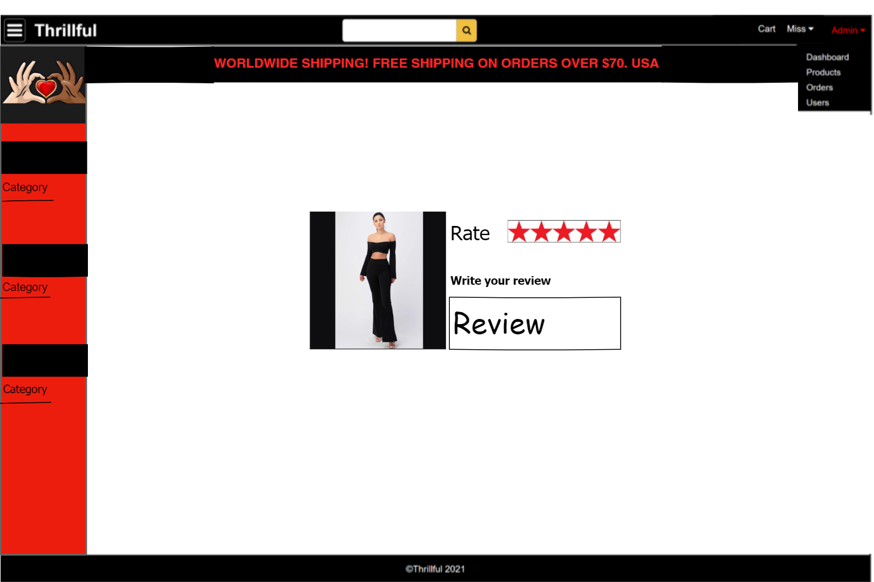

Figure 3

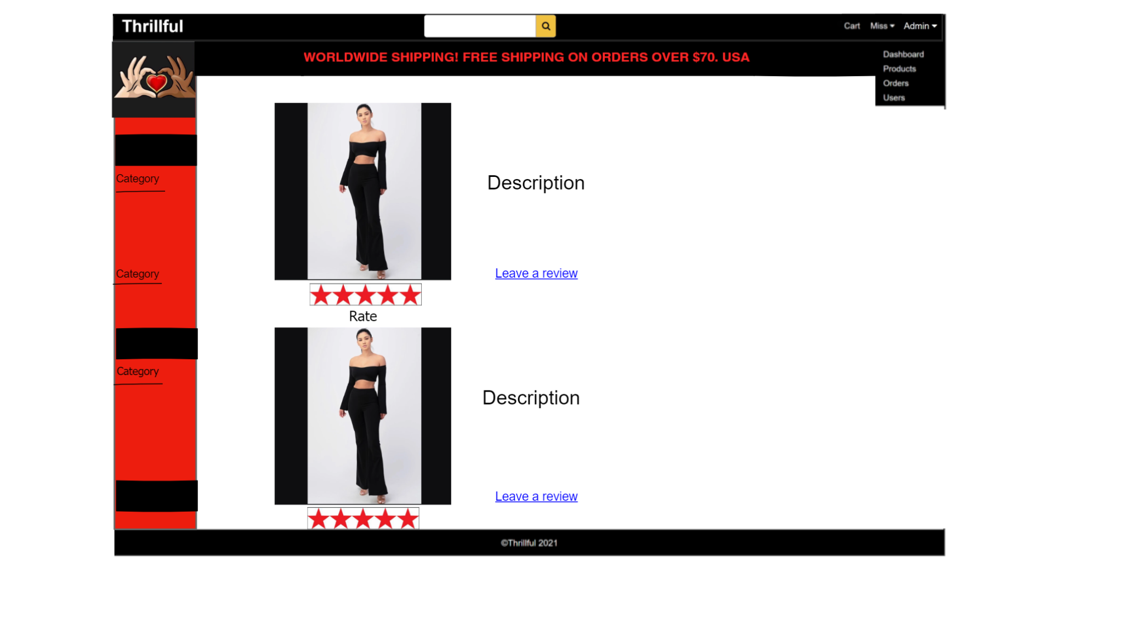

Figure 4

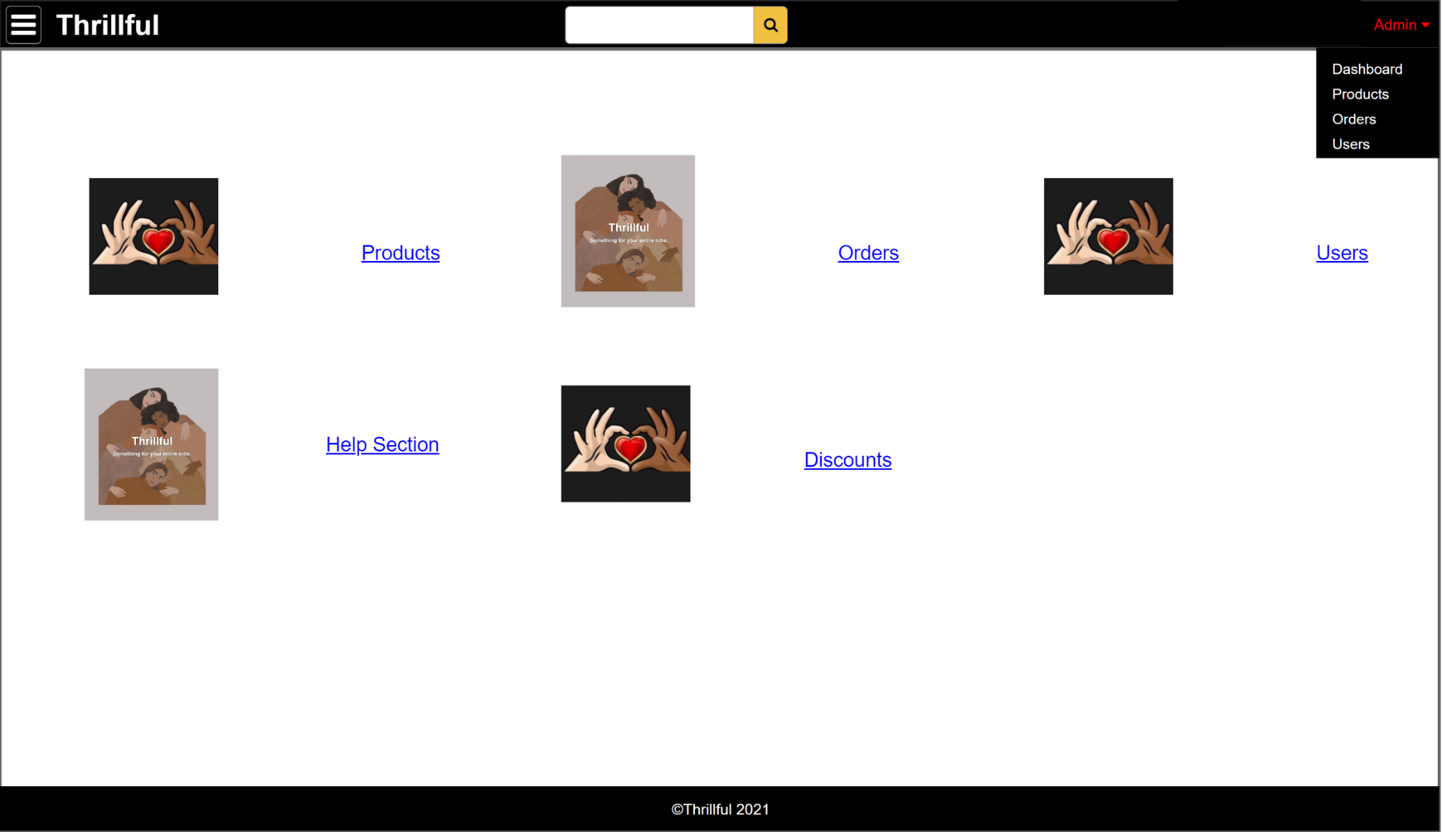

Figure 5

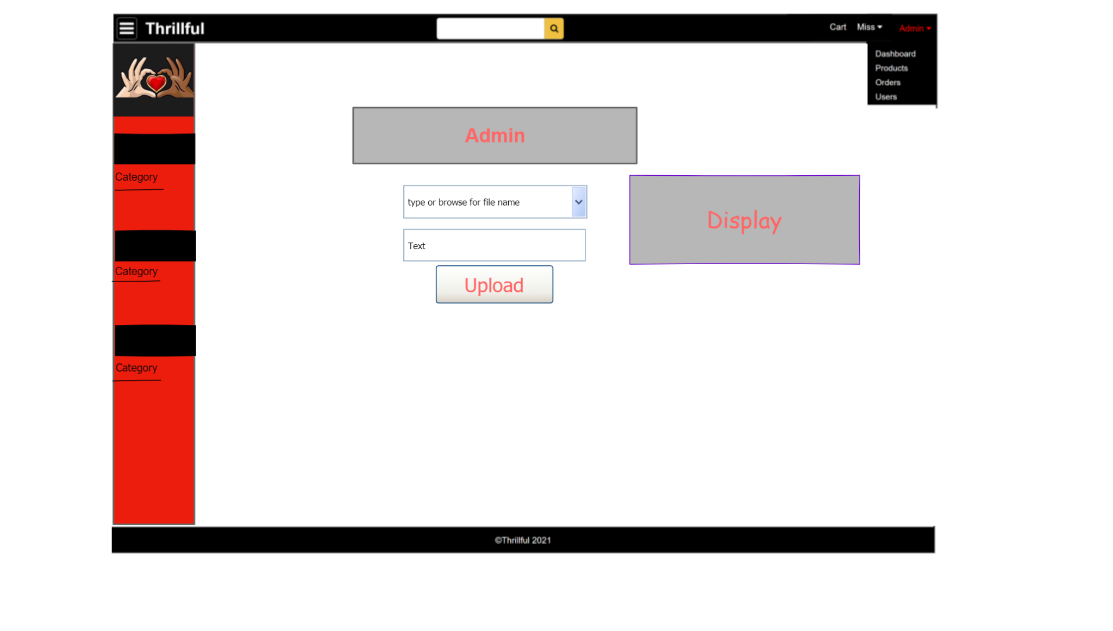

Figure 6

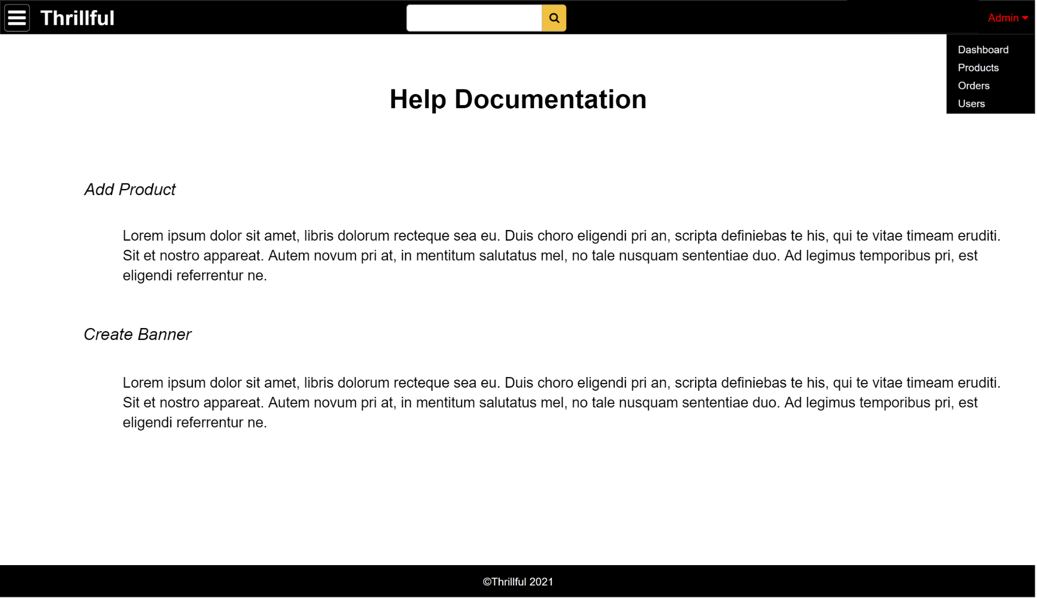

Figure 7

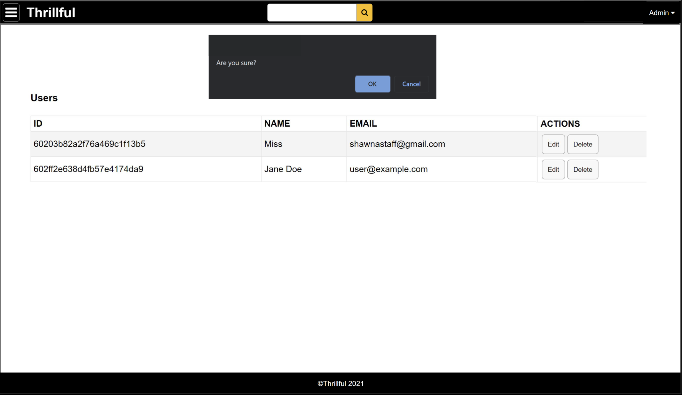

Figure 8

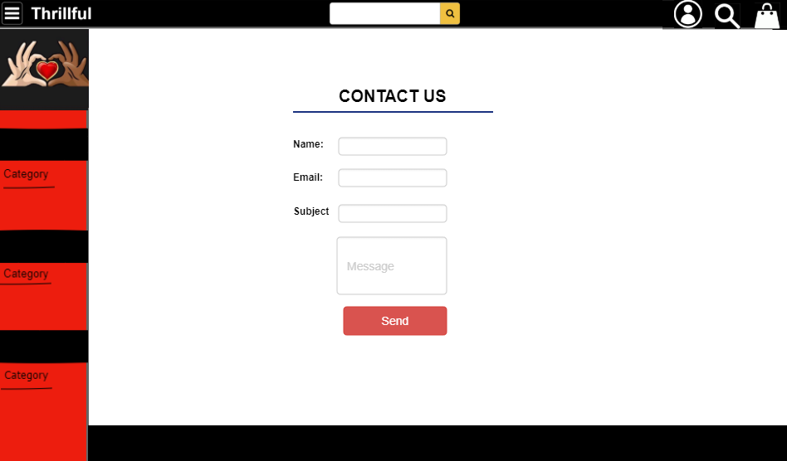

Figure 9

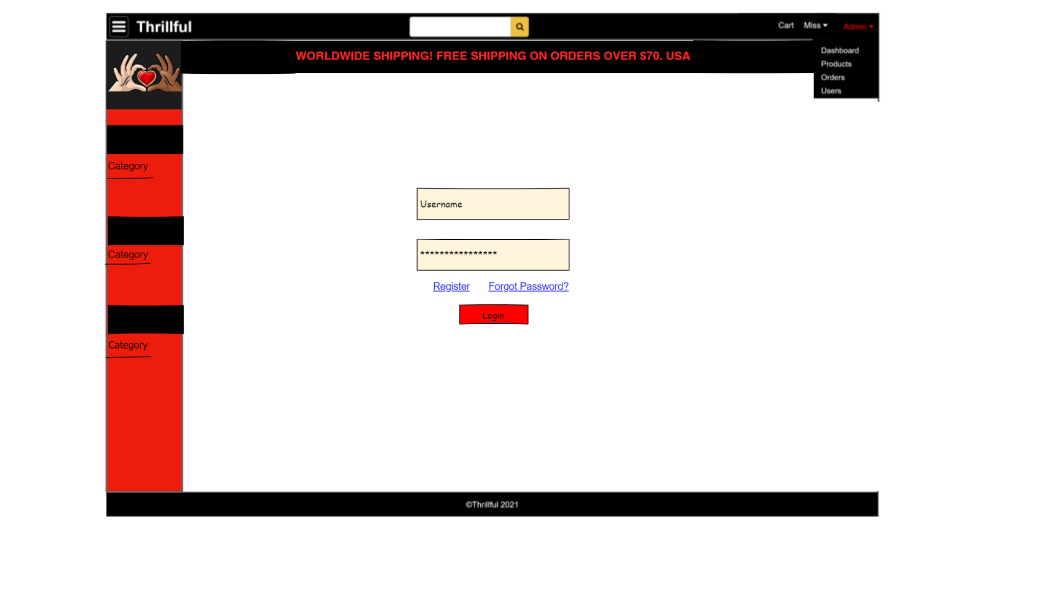

Figure 10

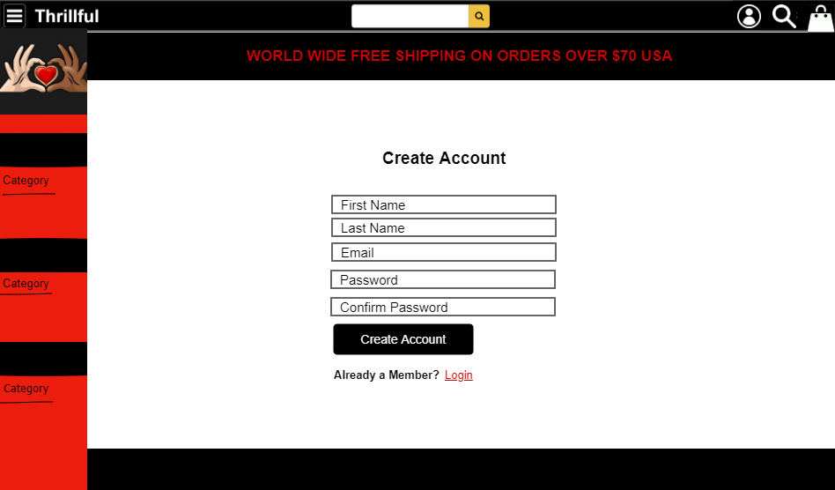

Figure 11

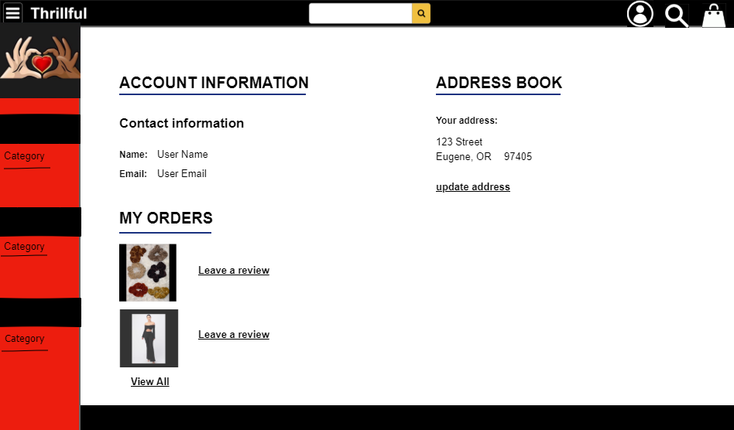

**Schedule**

**Sprint 1**

**3/28/21-4/10/21**

* Admin Dashboard/ Admin Product CRUD/Admin CRUD discount/banners

**Sprint 2**

**4/11/21-4/24/21**

* Connect Shopify backend, to manage customer cart and checkout

**Sprint 3**

**4/25/21-5/8/21**

* User Search & Category Navigation / User Product View and product page

**Sprint 4**

**5/9/21-5/22/21**

* User Registration/User Profile/User Review and Ratings

**Sprint 5**

**5/23/21-5/29/21**

* Debugging/Testing